Wind energy
How can you harness the energy in the wind to generate electricity?
Get familiar with how wind turbines work for power generation. Don’t worry if it appears complex. We will present the theory, then design and test simple wind turbines in class.
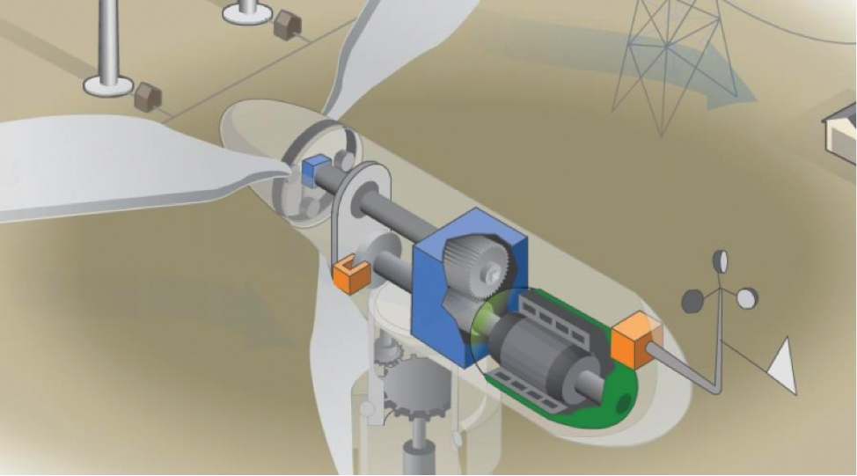
Use the links below to learn about wind turbines.
How wind Turbines work:
http://energy.gov/eere/wind/how-do-wind-turbines-work
http://www.explainthatstuff.com/windturbines.html

Wind turbine (blade) design
http://www.gurit.com/files/documents/2aerodynamicspdf.pdf
http://www.learnengineering.org/2013/08/Wind-Turbine-Design.html
http://science.howstuffworks.com/environmental/green-science/wind-power3.htm

