Water supply
I have a well, or a stream close to my farm, but not close enough. I want to water the crops in my farm, or my nursery, but I don’t want to fetch bucket after bucket. What do I do? I buy a pump! Or even better, I build one!
Pumps work by creating a partial vacuum at the desired point so that water (or any other fluid) will flow in response to this pressure difference.

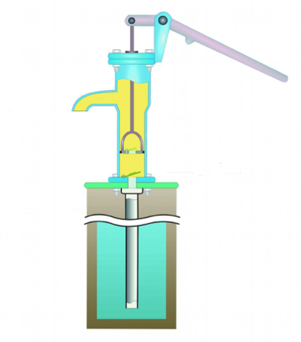
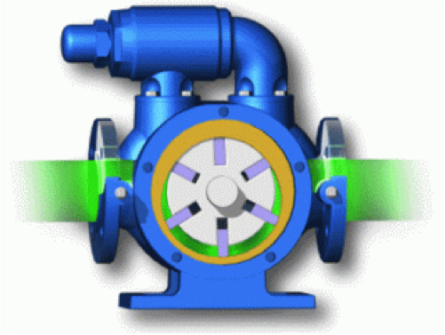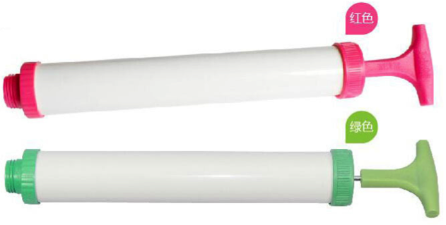

Want to know more about how pumps work? Then you know what to do. Use the link below for a very entertaining discussion on how pumps work. And pay attention! You will be building one yourself soon.
http://www.robinsons1874.com/Honda/pumps/Honda_pumps_principles.html

