Solar (thermal) energy
Solar energy is abundant, but very at relatively low intensities. You can try boiling water by simply leaving the pot in the sun! But can you actually boil water with the sun? That’s where solar concentrators come in. They collect solar radiation from a wider region and focus it on a much smaller area. Suddenly, you can do a host of things with the sun now, from boiling water to roasting chicken legs!!!
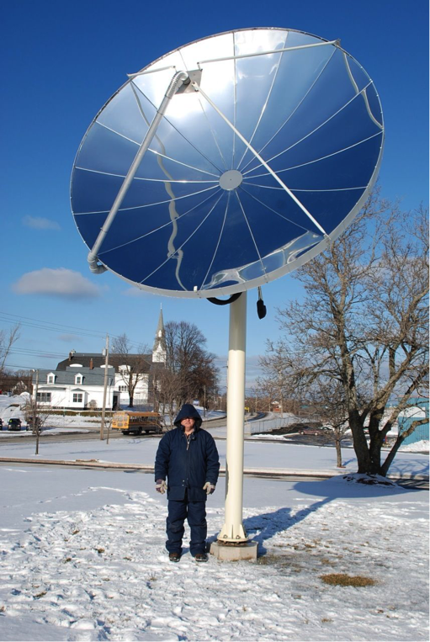
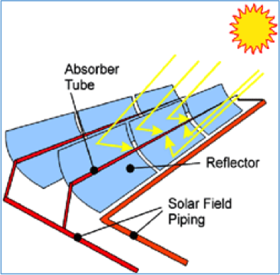
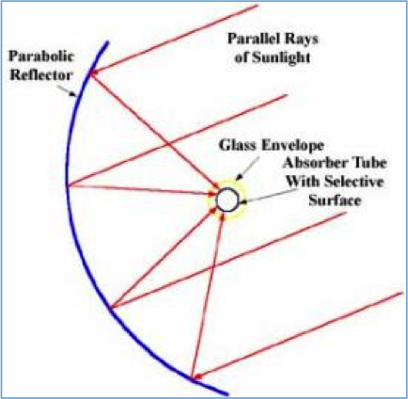

Check out the links for some overview on solar thermal power and get ready! You’ll be cooking your lunch with the sun!
Useful Links
http://science.howstuffworks.com/environmental/green-tech/energy-production/solar-thermal-power.htm
https://en.wikipedia.org/wiki/Concentrated_solar_power

