Internet of Things

Did you ever get a close shot at using the internet? From 2go, Whatsapp, Facebook and Twitter to the very powerful Google search engine. They all come in very handy when we need them! But what about the idea of having the internet tell your dad that you took his car out from the garage? Imagine that movie you've been planning to watch and luckily for you, dad travels to the UK for a business trip only for him to return and asks you why you had to go to the city mall with his car. Now that's the bad part...

Check out the link below and begin to whet your appetite on how things, ranging from your dog's kernel door and house appliances to the most mission critical fuel nozzles, supplying fuel to the Airbus A320 engine communicate with other things like your Samsung Galaxy S6 over the internet. It's just a world of unimaginable possibilities!
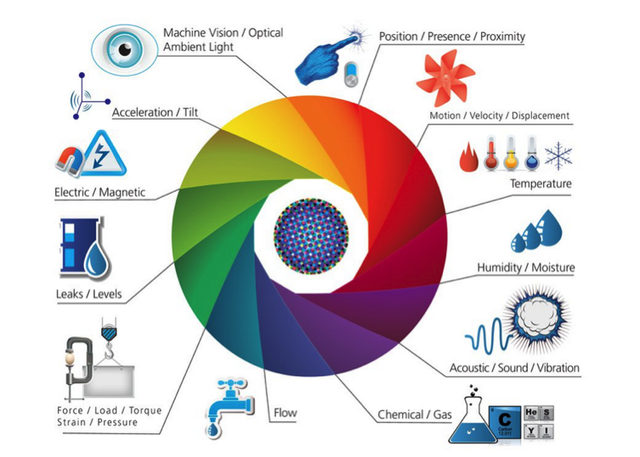
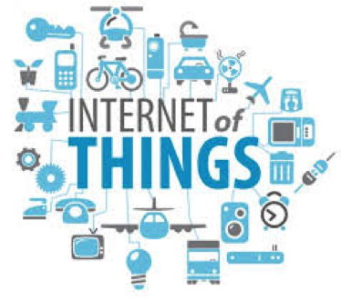

Required reading:
https://en.wikipedia.org/wiki/Internet_of_Things

Try to answer the following:

What do you understand by microcontrollers? How do they work?
What does the arduino platform stand for and how can you use it to power the Internet of Things?
What are sensors? Differentiate between analog and digital sensors.
What are possible applications of IoT in health/Agriculture/sanitation

The following links should help you find answers:
http://carre-strauss.com/documents/IoT_Roadmap.pdf
http://ieeexplore.ieee.org/stamp/stamp.jsp?reload=true&arnumber=6740844
http://www.internet-of-things-research.eu/documents.htm
http://www.internet-of-things-research.eu/pdf/Converging_Technologies_for_Smart_Environments_and_Integrated_Ecosystems_IERC_Book_Open_Access_2013.pdf

