Computer Aided Design

Computer Aided Design (CAD) makes the work of the designer easier by enabling him or her to create, modify and optimize designs. Indeed with CAD, you can create anything! Ok, maybe not quite, but you can do a whole lot; and it provides you with visualization capabilities that makes it worth every effort you put into learning it.
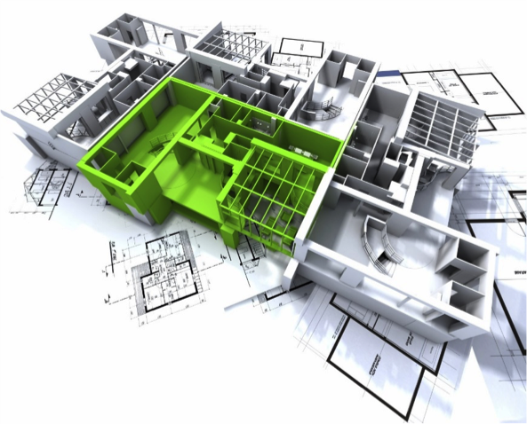


There are many CAD softwares available for creating 3D designs. Because it is free and versatile, we recommend that beginners use Sketchup.
Software Download Link:
http://www.sketchup.com/

Tutorial Links:
http://www.sketchup.com/learn/videos/58
http://www.lynda.com/Google-SketchUp-training-tutorials/953-0.html
http://help.sketchup.com/en/article/36207

