Big Data Analytics

Have you ever thought about the amount of data that can come from the seemingly trivial activities you do everyday like walking, eating, reading and even sleeping? Can you guess the average amount of neural messages generated in your body and that goes to and from the brain daily? To give you some idea... Facebook stores, accesses and analyzes over 30, 000 terabytes of data while Youtube users upload 48 hours of video every minute which is equivalent to 120 days of video per day. An average jetliner produces about 10 terabytes of sensor data per 30 minutes of flight while the human brain can hold up to 1.25 terabytes of data (think of five 250GB hard disks stacked in your skull!).
While a lot of insight can be gleaned from this vast data to help make intelligent decisions, the sad part of the story is, more than 80% of this data cannot fit into a database, or at least, the regular relational databases.

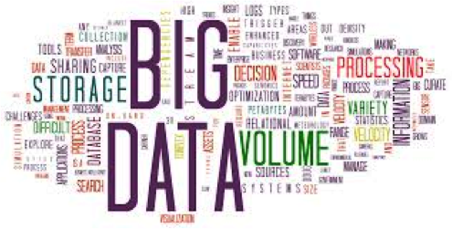
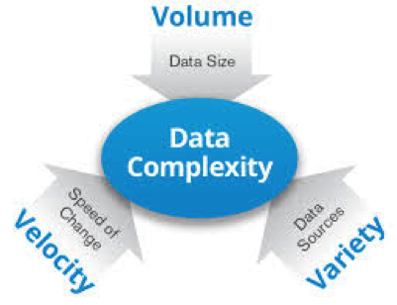

How then can you conveniently mine the wealth of insight this huge amount of data presents? Big Data and Analytics Technologies provide a lot of answers to this. Where and how do you find this answers?

Read more on what Big Data Analytics is from the following sites:
-https://en.wikipedia.org/wiki/Big_data
-http://analyticstraining.com/2014/explaining-big-data-to-kids/
-http://www-01.ibm.com/software/data/bigdata/
-http://datascience.berkeley.edu/what-is-big-data/

Think of possible applications of Big Data with IoT in health/agriculture/sanitation.

You should sign up for a trial account on IBM Bluemix and start learning Bluemix app development on the Developers page.

Additional resources:
http://bigdatauniversity.com/wpcourses/

